Grazioso Salvare Dashboard
Developer: Kashish G. Prajapati
Course: CS 340 – Client/Server Development
Project Two – MongoDB Dashboard Application

1. Project Overview
For this project, I developed a full-stack dashboard application for Grazioso Salvare, an organization that trains rescue dogs for different types of search-and-rescue missions. The goal of the dashboard is to help users quickly identify dogs from the Austin Animal Center dataset that meet specific criteria for rescue training.
The application connects to a MongoDB database using a custom Python CRUD module that I developed in Project One. I then built an interactive dashboard using Dash that allows users to filter, view, and analyze the data in real time.
The final result is a working web-based dashboard that allows users to:
- Filter dogs by rescue type
- View matching results in a data table
- See a dynamic breed distribution chart
- View animal locations on an interactive map

2. Required Functionality and Proof of Execution
The dashboard includes all required components outlined in the project specifications:
- Grazioso Salvare logo
- Unique identifier with my name
- Interactive rescue-type filtering options
- Interactive data table
- Dynamic breed distribution chart
- Geolocation map
- Reset functionality
Below are screenshots that demonstrate the successful execution of each required feature.

Screenshot 1: Water Rescue Filter Applied
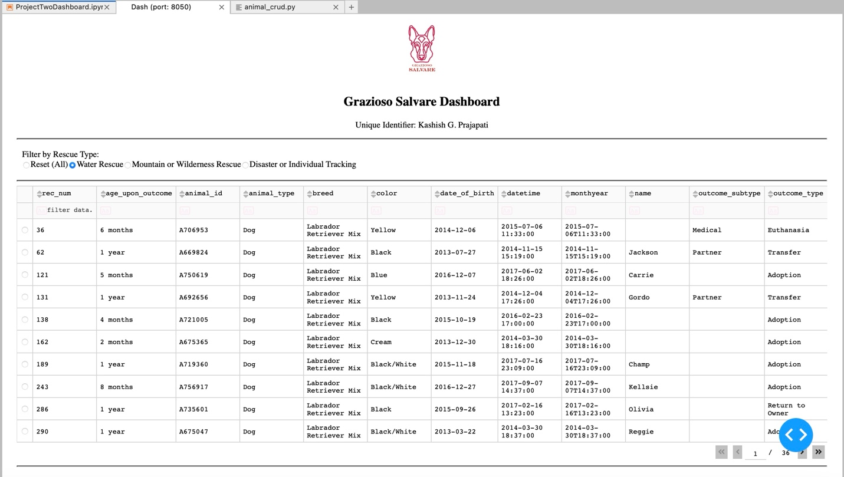

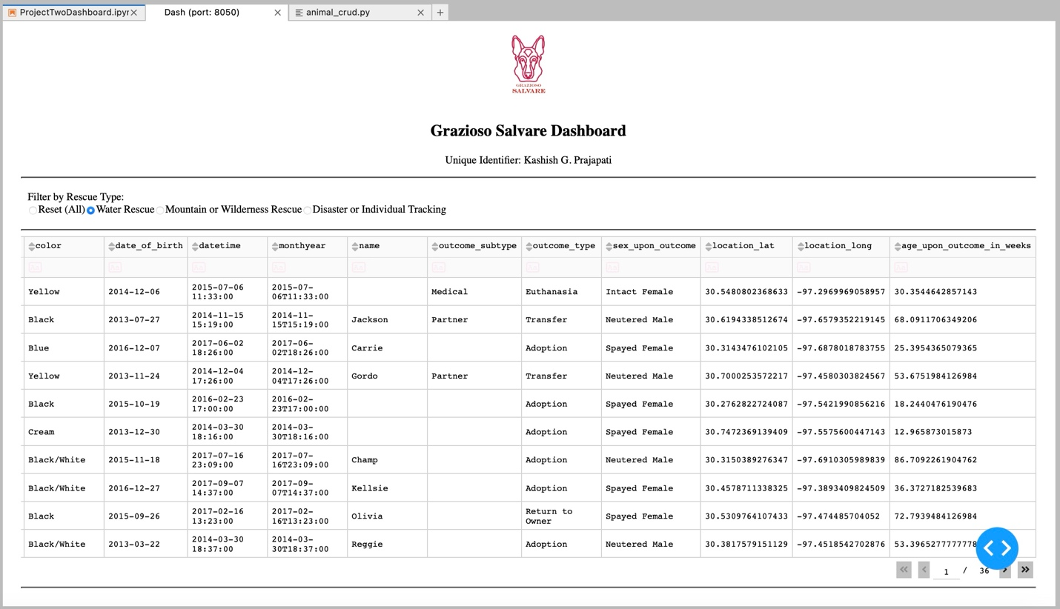

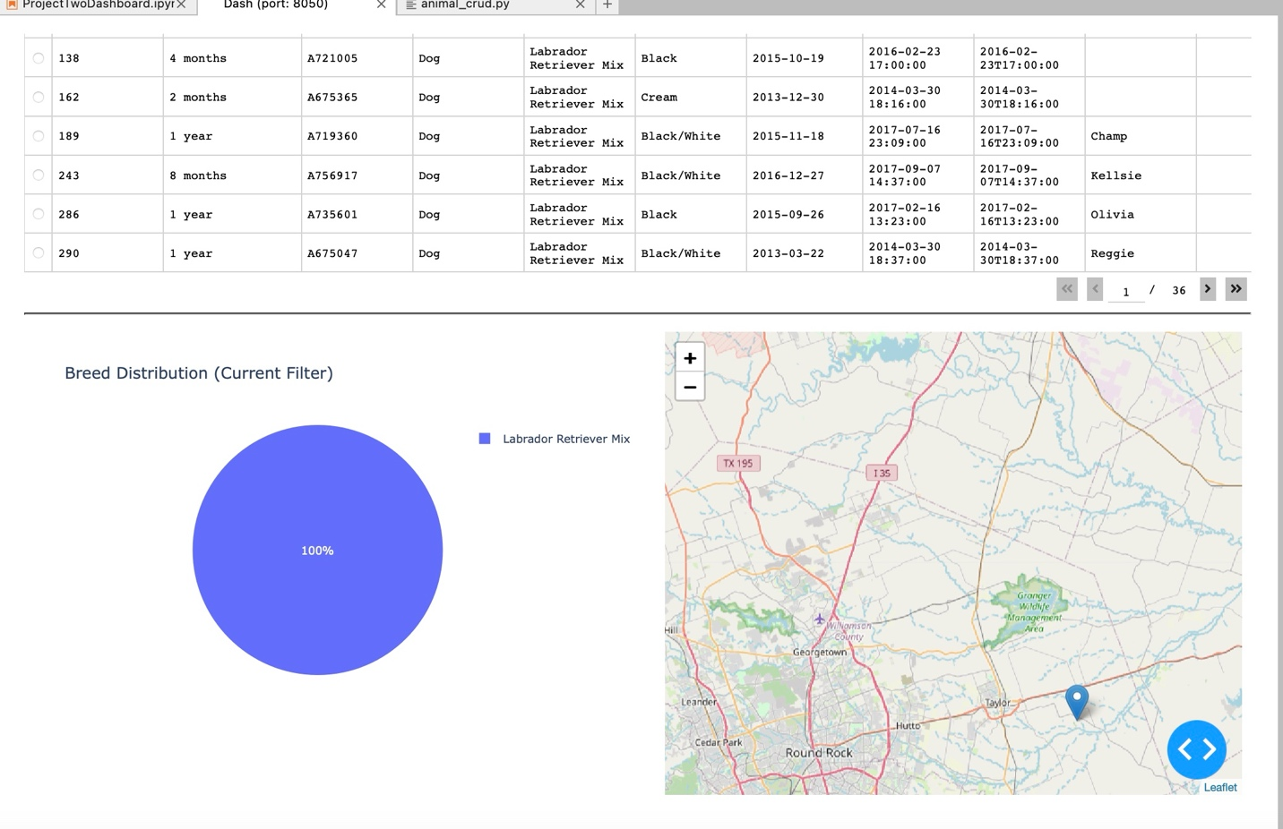

This screenshot shows the dashboard after selecting the “Water Rescue” filter. The data table updates to show only matching dogs, and both the chart and map reflect the filtered data.

Screenshot 2: Mountain or Wilderness Rescue Filter Applied
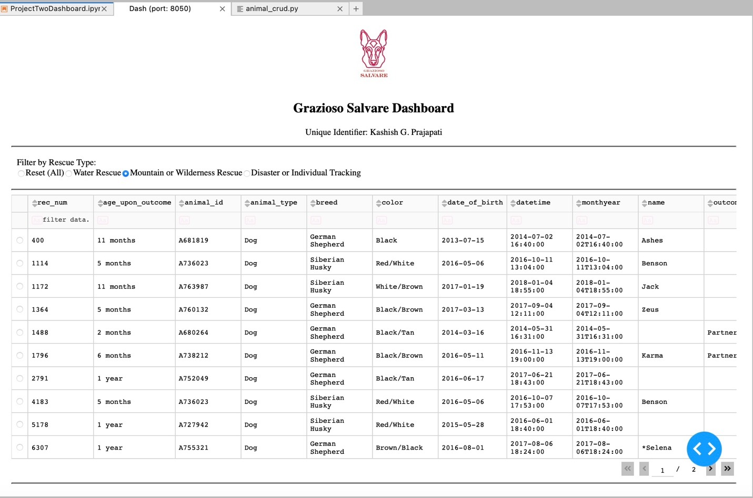
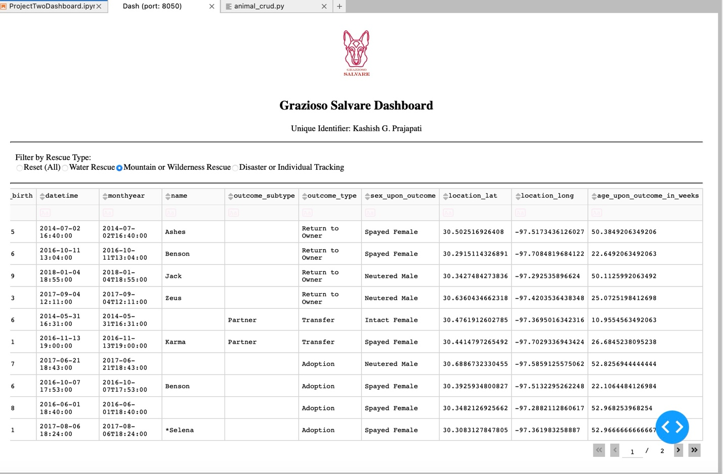
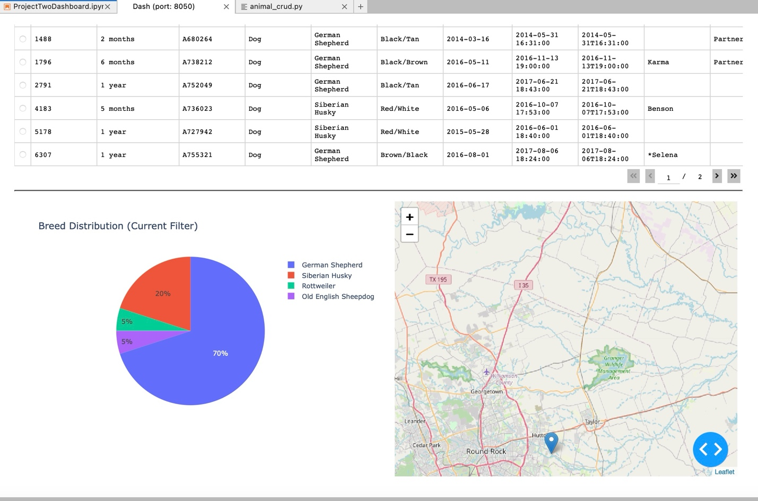
This screenshot shows the dashboard after selecting the “Mountain or Wilderness Rescue” filter. All components update dynamically based on the selected criteria.
Screenshot 3: Disaster or Individual Tracking Filter Applied
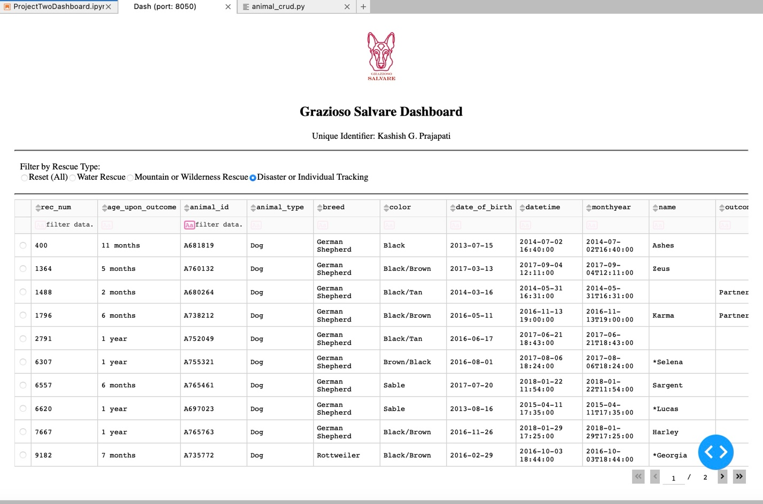
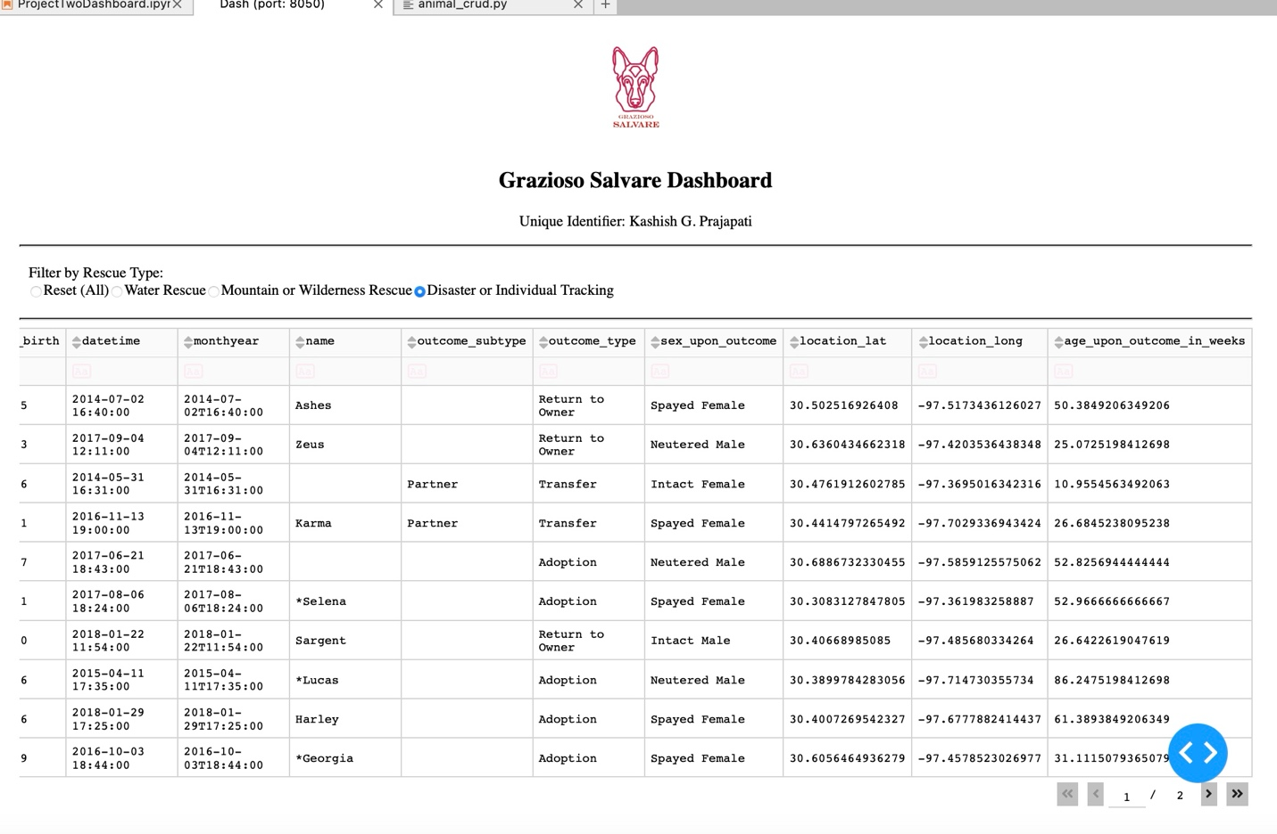
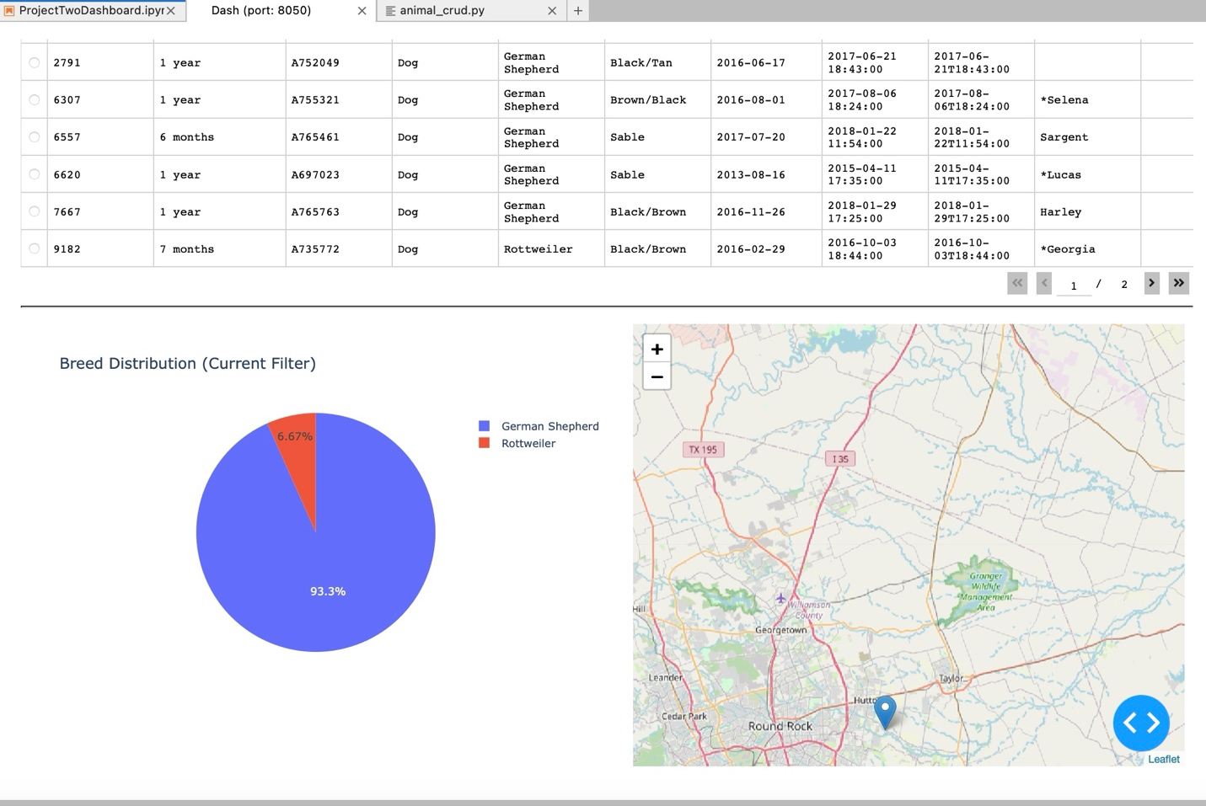
This screenshot demonstrates the filtering for “Disaster or Individual Tracking.” The table, chart, and map respond correctly to the selection

Screenshot 4: Reset Functionality

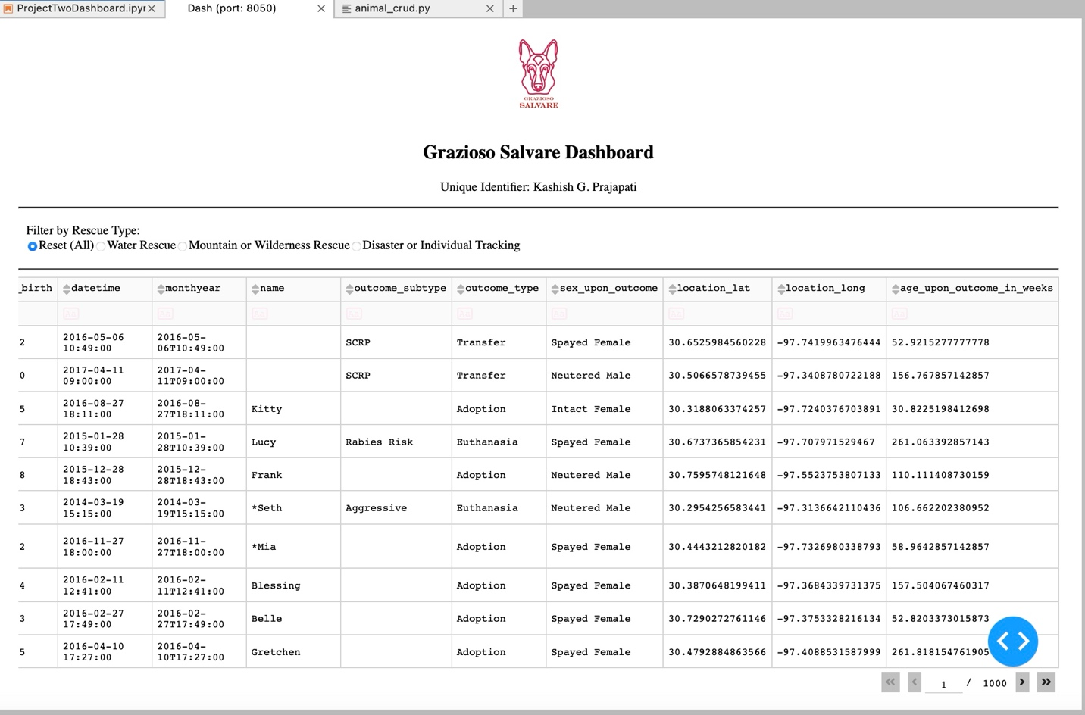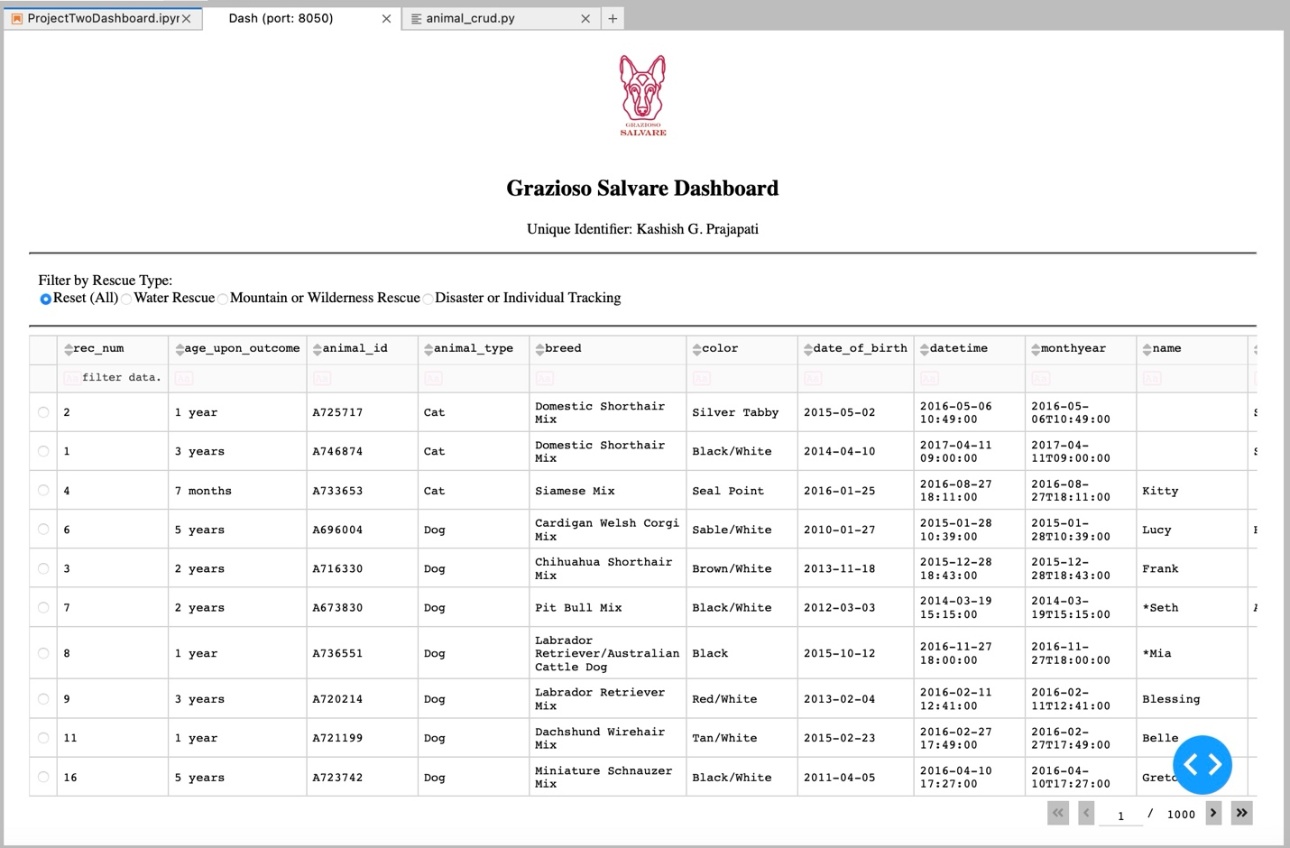

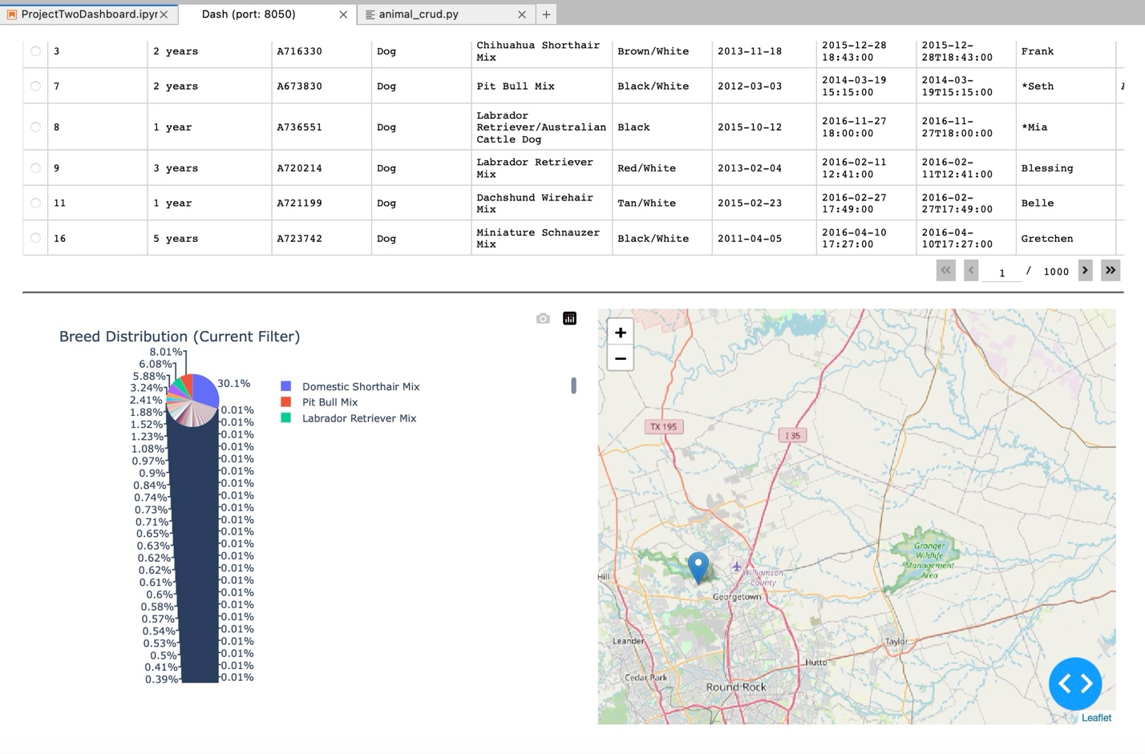
This screenshot confirms that selecting “Reset (All)” returns the dashboard to its original unfiltered state.

3. Tools and Technologies Used

MongoDB (Model)
MongoDB was used as the database for this application. Since the dataset contains multiple fields and varied data types, MongoDB’s flexible document structure works well for this kind of project.
MongoDB integrates smoothly with Python using PyMongo, which made it straightforward to build custom CRUD operations. Using operators like $in and $lte, I was able to create filtering queries that match the rescue criteria provided in the specifications.
The AnimalShelter CRUD module serves as the bridge between the dashboard and the database.

Dash (View and Controller)
Dash was used to build the web application interface. I chose Dash because it allows full web applications to be built entirely in Python, without requiring JavaScript.
Dash uses a callback system that connects user interactions (like selecting a filter) to backend database queries. This makes it ideal for creating dynamic dashboards where the interface updates automatically when the data changes.
The dashboard follows the MVC design pattern:
- Model: MongoDB database
- View: Dashboard components (table, chart, map)
- Controller: Dash callbacks that trigger database queries

JupyterDash
JupyterDash allowed me to run the Dash application directly inside the Codio Jupyter environment. This simplified testing and deployment during development.

4. Steps Taken to Complete the Project
To complete this project, I followed these steps:
- Imported the Austin Animal Center dataset into MongoDB.
- Developed a Python CRUD module to handle database operations.
- Created the dashboard layout using Dash components.
- Built MongoDB queries based on rescue type and preferred dog breeds.
- Connected radio button filters to database queries using Dash callbacks.
- Linked the filtered table data to both the pie chart and map.
- Added the Grazioso Salvare logo and unique identifier.
- Tested each filter to ensure that all components updated correctly.
- Captured screenshots to document successful execution.

5. Challenges and How They Were Resolved
One challenge involved loading the logo file correctly. The file path initially caused an error due to directory structure issues. I resolved this by verifying the working directory and adjusting the relative file path.
Another challenge was ensuring that the table, chart, and map all updated consistently when filters were applied. This required careful setup of Dash callbacks and proper handling of empty or missing data to prevent errors.
Building the correct MongoDB queries also required careful use of operators and testing to ensure the filters returned accurate results.

6. Instructions to Reproduce This Project
To reproduce this dashboard:
- Install MongoDB locally.
- Import the Austin Animal Center dataset into a database named aac and a collection named animals.
- Ensure that the animal_crud.py file is present in the same directory as the notebook.
- Install required Python libraries:
  - pymongo
  - dash
  - jupyter-dash
  - dash-leaflet
  - plotly
  - pandas
- Open ProjectTwoDashboard.ipynb.
- Run all cells.
- Access the dashboard through the JupyterDash link.

7. Conclusion
This project demonstrates the integration of database systems with a client-facing web application. By combining MongoDB, Python, and Dash, I was able to create a fully interactive dashboard that allows Grazioso Salvare to efficiently identify dogs suitable for different rescue missions.
The final product meets all specified requirements and provides a clean, user-friendly interface for interacting with shelter data.

